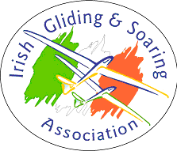 | Irish Gliding and Soaring Association  Form 211 Work Order Form

EI-G | Aircraft Type: |  | Serial No:
Owner/Operator name and address: |  |  | IGSA PART-CAO
Form Reference:
Details of work requested: (Circle appropriate box)
Annual Maintenance |  | ARC extension or renewal
Details of other work:

Customer Supplied Data revision status
As
- IGSA CAO or
- Owner/Operator (for aircraft in the uncontrolled environment only)

I authorise the IGSA CAO facility to carry out the Maintenance work as detailed.
I understand and agree that the IGSA CAO facility may store my personal contact details in paper and electronic format.

Signed………………………….. Name:……………………..

Date:

IGSA CAO Authorisation (if applicable) ……………………
IGSA Form 211 Issue 1 Revision 3; September 2021

